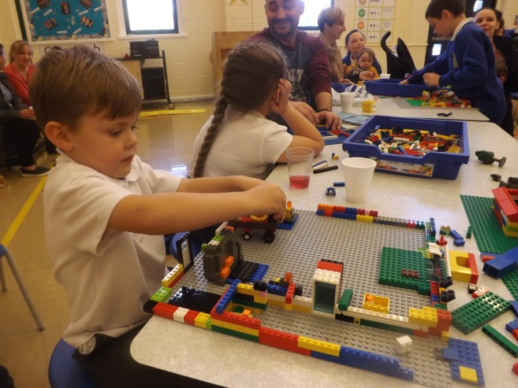
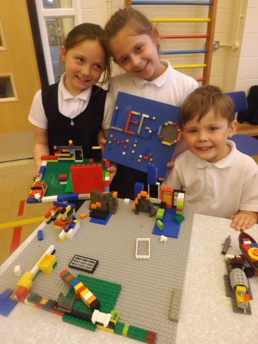

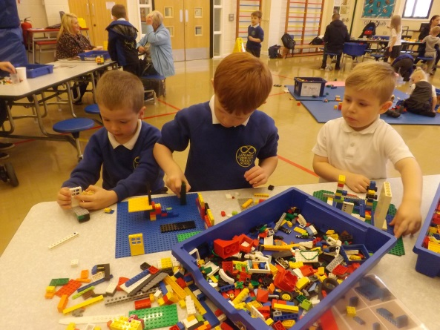
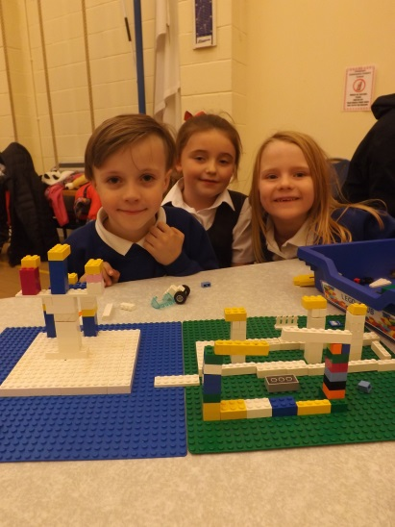

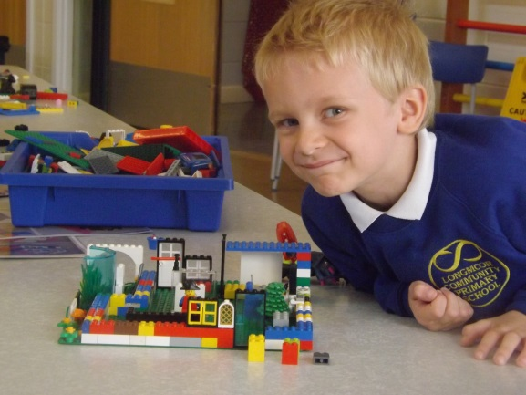
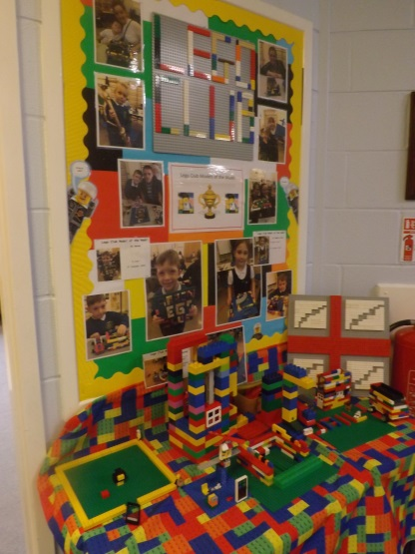

Lego Club Newsletter
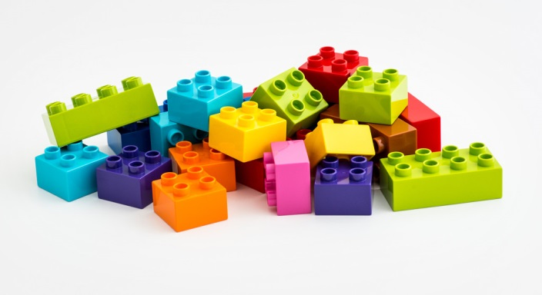

  - 1st December 2016

Firstly, a great big thank you to all of you for turning up to Lego Club every week – it wouldn’t work without you!
Secondly, this will be the last Lego Club this term – too many Christmas events are scheduled for the hall in December! Normal service will resume in January 2017 though, and we’ll send a reminder.

No phones are to be used in school, for obvious reasons, so please don’t be offended if we ask you to put yours away. Thanks for your co-operation.

Model of the week – please rest assured that I will endeavour to make sure that everyone gets the recognition they deserve! Please be patient – it’s the most difficult job of the week to decide which model wins!

Tea, coffee, juice and biscuits will continue to be offered, but in the New Year, we are thinking of having a voluntary donation jar – the Friends of Longmoor currently kindly support us by purchasing all the refreshments, for which we are extremely grateful.

We take lots of photographs every week, and will try to establish a place on the website where these can be seen. Lego Club Book 2 is in progress…..watch this space.

All children must be accompanied by an adult – Lego Club was established for three main reasons:

- To encourage children and adults to communicate and play together;
- To allow parents to see Mrs Gough at a regular, set time each week if they need to;
- To have fun!

From Mrs Gough, Mrs Molyneux, Mrs Blanchflower and Helen.

