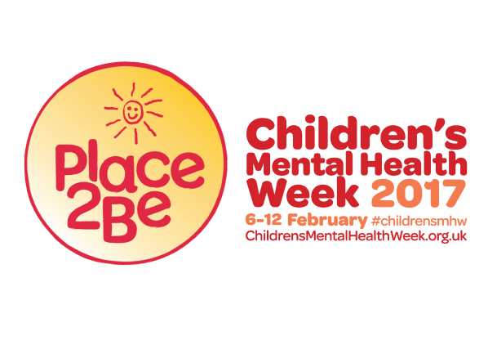
Children’s Mental Health Week 2017
8-14 February 2017
‘Spread a little kindness’

Children's Mental Health Week 2017
8-14 February 2017
We are proud to support Children’s Mental Health Week 2017 (8-14 February).
Many children go through tough times just like adults and in those moments, the smallest acts of kindness can make a big difference. That is why we are joining hundreds of other schools to ‘spread a little kindness’ by taking part in Children’s Mental Health Week.
The Week is hosted by children's mental health charity Place2Be, who support pupils, families and teachers in schools across the UK. During the Week, we will be spreading kindness throughout our local community. Further details will soon be sent home by your child’s class teacher, but here is a flavour of things to come:
- Nursery children are working with the PDSA, collecting food for local animals in need;
- Reception are supporting the North Liverpool Foodbank;
- Year 1 will be asking a local community nurse how they can help to spread a little kindness;
- Year 2 are working with the Whitechapel Centre (which supports homeless people);
- Year 3 are going to share stories with residents at Grace Lodge Nursing Home;
- Year 4 are working closely with a local foodbank, creating recipes to accompany food hampers;
- Year 5 are supporting Tweenie Tots 2 Community Childcare Service;
- Year 6 are working with Place2Be on fundraising ideas;
- The Union of Catholic Mothers will be visiting school to share with us the wonderful work they do in our area to support the local community.

We will also be holding a themed own-clothes day on Friday 10th February, where children are invited to come into school wearing red and/or yellow clothes (no football kits or tracksuits please!!!) to reflect the colours of Place2Be, for a suggested donation of £1.

If you would also like to get involved and support the campaign, Place2Be has created helpful advice and resources for parents and carers which you can find on their website: www.childrensmentalhealthweek.org.uk.

